RESUME

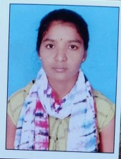

NAME

Chandana kandela

Phone : 6301770828

E-mail : [kandelachandana@gmail.com](mailto:kandelachandana@gmail.com)

# CAREER OBJECTIVE

To obtain a challenging position as a Software Engineer in a leading multi-national organization where I can use my qualifications and skills to prove my abilities.

# EDUCATIONAL QUALIFICATIONS

|  |  |  |  |  |  |  |
| --- | --- | --- | --- | --- | --- | --- |
| S.  No. | Examination Passed | Name  of Institute/ University | Discipline/ Subject | Month & Year of  Passing | Percentage of  Marks | Division |
| 1. | B. Tech | Ace Engineering College  Ghatkesar. | Artificial intelligence and machine learning | 2025 | 8.0 | First |
| 2. | Intermediate | Sr junior college Nizamabad | Maths, Physics, Chemistry. | March 2019-  21 | 82 | First |
| 3. | S.S.C | Telangana State Model School | Maths, Science,  Social Studies | March 2019 | 97 | First |

TECHNICAL PROFILE

Languages : C , PYTHON.

ACHIEVEMENTS

NPTEL Certificate: The Joy Of Computing Using Python ACE CODE PRAGNA: Round 1 and round 2 Cisco:Essentials in c

Cisco:Essentials in python

# STRENGTHS

Positive Attitude

Patience.

# WEAKNESSES

Have a difficulty in saying NO

# HOBBIES

Reading Books

Travelling

Dancing

# PERSONAL PROFILE

Date of Birth : 21st may 2003 Languages known : English, Telugu. Father's Name : Mr. Gangadhar

Mother’s Name : Mrs. Sujatha

Address : H-no.3-18/2 Badguna,Nandipet Nizamabad 503212

# DECLARATION :

It is hereby acknowledged that the information furnished above is true to my knowledge.

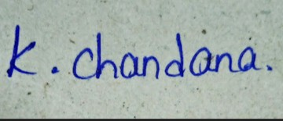

Place : Hyderabad Signature

Date : 11/11/2022

* * *